**Text file for HIVE commands:**

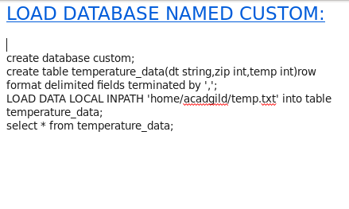

**Show and create database custom:**

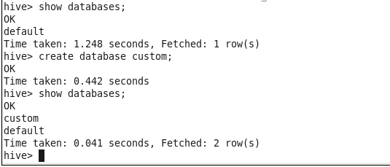

**Create Table**



**Load Data**

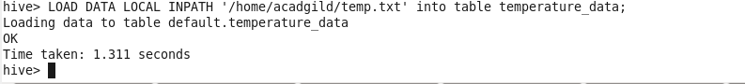

**Display Data:**

